Prepared by the  U.S. Air Force PKI System Program Office (SPO) | Implementation, Training, and Technical Support of the  Department of Defense  Class 3 Public Key Infrastructure (PKI)  For the United States Air Force
 | User Guide for the Air Force Home Use Middleware Package
 | V2.0.0.0
 | September 2008
Deliverable No.
OE-09-45-006

Contents
1. Introduction 1
1.1 Purpose 1
1.2 Terms of Use 1
1.3 Risks 1
1.4 Disclaimer of Liability 1
2. Middleware and Reader Installation Instructions 2
2.1 Required Items 2
2.2 Middleware Installation Instructions 2
2.3 Smart Card Reader Installation Instructions 13
2.4 Verify Installation Success 15
3. Uninstall Instructions 16
3.1 Uninstall Home Use Middleware 16
4. Technical Support 20

Introduction

Purpose
This document provides instructions on how to install and uninstall the Home Use Middleware (ActivClient 6.1, Air Force (AF) release) and information regarding smart card readers and technical support.
Read all installation instructions prior to installing the Home Use Middleware and a smart card reader and drivers.

Terms of Use
The Home Use Middleware you are about to install is the property of the United States Air Force (USAF) and is provided for use on a personal, non-government furnished computer. This product is distributed under licenses restricting its use, duplication, and distribution. It is intended For Official Use Only (FOUO) for accessing Department of Defense (DoD) and USAF Web sites, systems, and networks with the Common Access Card (CAC). It is authorized for use by active duty, Air National Guard (ANG), Air Force Reserve (AFRES), civil service, Non-Appropriated Fund (NAF), and DoD contractor personnel.
Distribution to non-AF employees is not authorized.
By installing and using this Home Use Middleware, you signify your agreement to the terms and conditions set forth. If you do not agree to this Agreement, do not install or use this product.

Risks
There are potential risks associated with installing this package. It is not possible to test this middleware with all software, games, and/or applications that are commercially available and that may be on your home computer. Therefore, it is possible that the Home Use Middleware could conflict with other applications or software residing on your home computer.

Disclaimer of Liability
With respect to installing and using Home Use Middleware, neither the DoD nor USAF, nor any units or employees within, provide any warranty, expressed or implied, or assume any legal or financial liability or responsibility for your non-government computer system and/or damages or repairs that may result from system incompatibilities with Home Use Middleware.

Middleware and Reader Installation Instructions

Required Items
- CAC
- Smart Card Reader
- System requirements:
Component | Version | Minimum | Supported
Operating System | Windows 2000 | Service Pack (SP) 4 | SP4 and above
Operating System | Windows XP (Home or Professional) | SP 2 | SP2 and above (does not support Windows Media)
Operating System | Vista (all editions) | Original | 32-bit version
Browser | Internet Explorer | 6.0 | Original and higher

Note: On Windows Vista platforms, to enable Secure/Multipurpose Internet Mail Extensions (S/MIME) (digitally signing and encrypting/decrypting email) in Outlook Web Access (OWA), the User Account Control feature must be disabled.

Middleware Installation Instructions
Important: Before installing, deactivate your virus scanning software and anti-spyware! You should disconnect your computer from the Internet prior to deactivating your virus scanning software.
Note: Depending on the operating system in use (Windows XP, Vista, or 2000), the screen shots may vary but the information should be the same.
** Required: EXTRACT all the files from the zip folder
PRIOR to running the install **

- If using Windows 2000, you will need an unzip tool. Numerous free evaluation versions of unzip utilities are available on the Internet, and come with instructions. (You can also consult your local Client Support Administrator (CSA) for assistance). If using Windows XP or Vista without an added unzip utility, right click on the file named HomeUseSW and choose the “Extract All” option.
Windows XP Screenshot
Windows Vista Screenshot
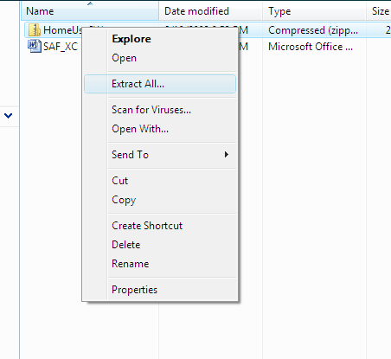

- To extract the files:
For Windows XP:
- Click on the “Next” Button
- Determine where to extract the files, and click the “Next” button.
- Click the “Finish” button

For Windows Vista:
- Type or browse to the directory where you want the files extracted and click the “extract” button.
- Open the “Install Software” folder
Windows XP Screenshot
Windows Vista Screenshot

- Double click the file titled “ClickHeretoInstallorUninstall” to begin installing ActivClient 6.1 Home Use Middleware.
Windows XP Screenshot
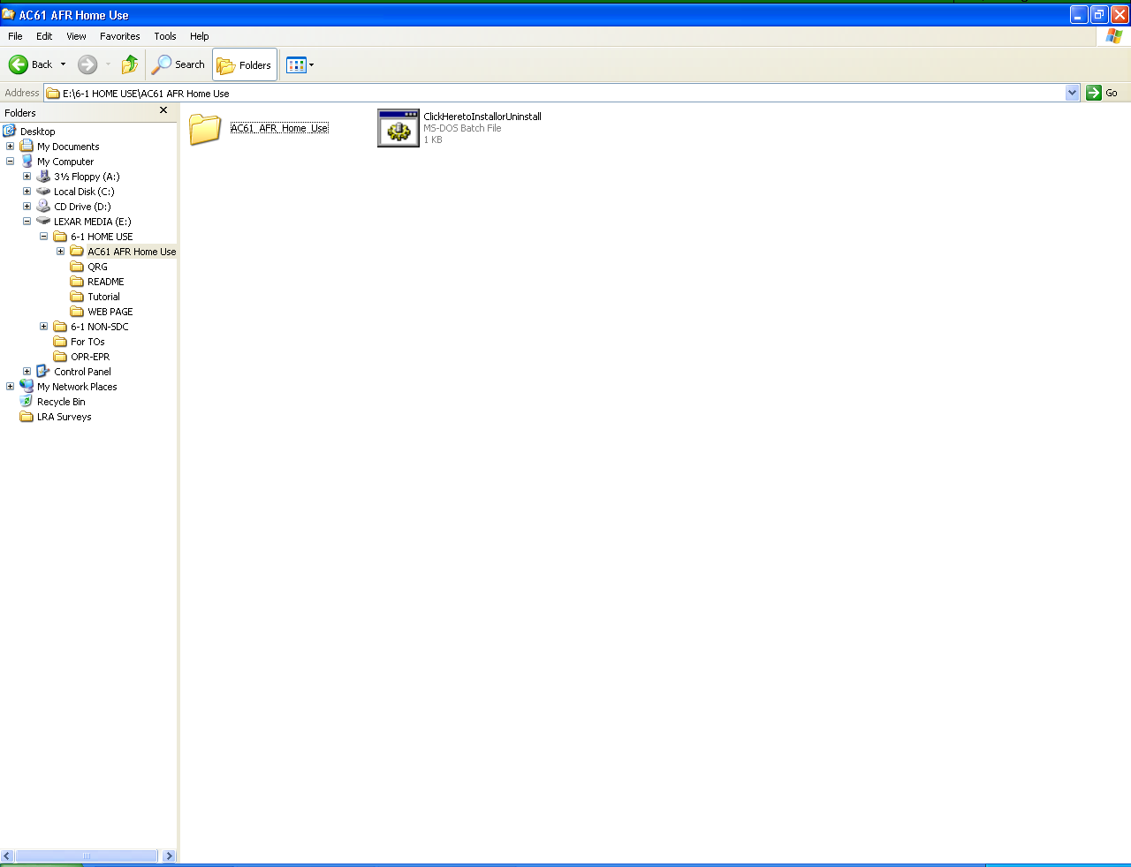
Windows Vista Screenshot
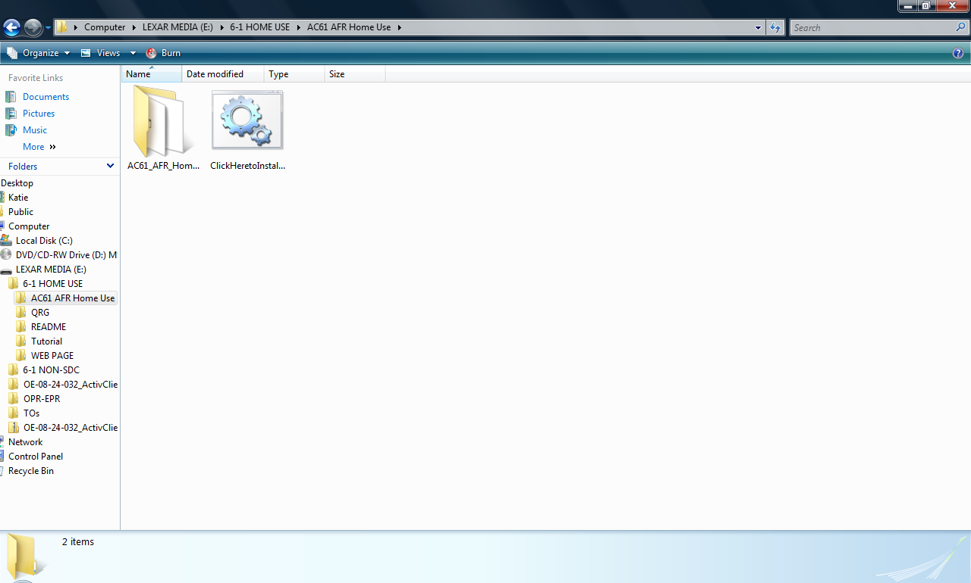
- You will see a black screen pop up followed by a blue installation screen.
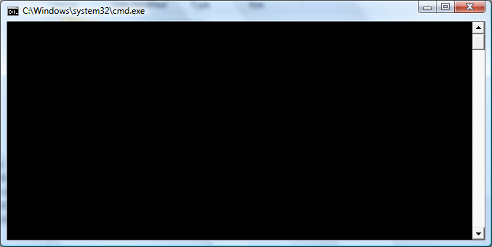

The black screen may become hidden by the blue installation screen.
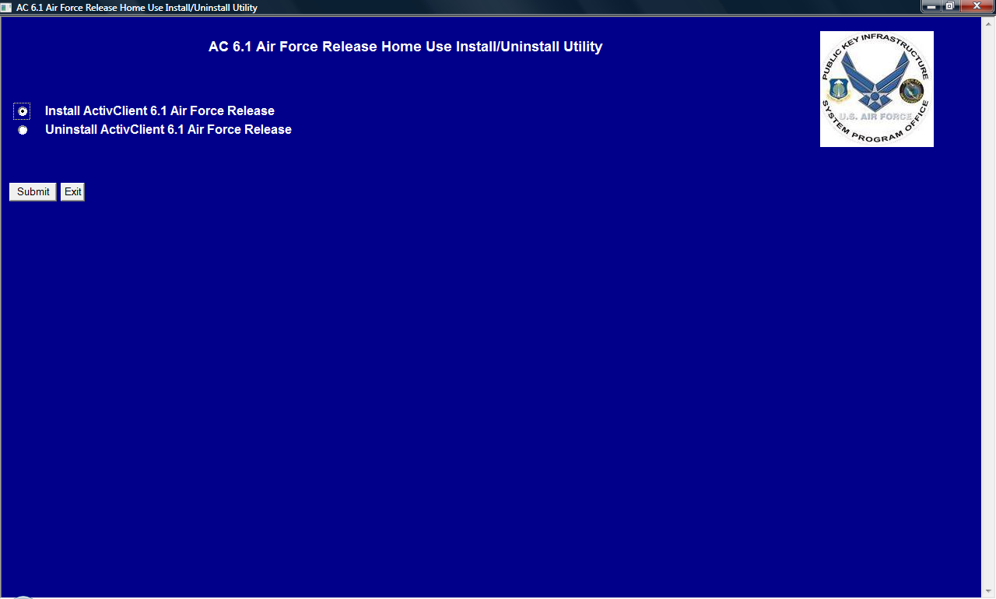
- Select the first option (above)… Install or Update ActivClient 6.1 Air Force Release. Click Submit.
Note: If a smart card reader is not already installed, you may receive a prompt indicating you have not yet installed a smart card reader. Click OK and continue installing the middleware.
- The AC 6.1 Air Force Release User Agreement will pop up. Carefully read the User agreement. Select the first option to accept the agreement, and click Submit. If you choose to not accept the agreement, the installation will stop.
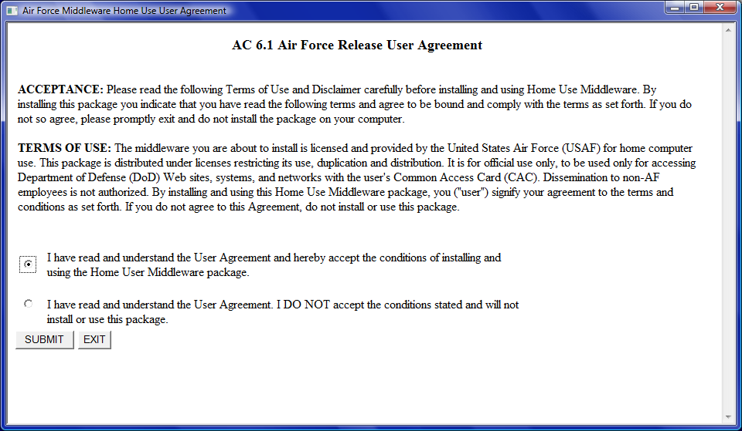
Note: In Windows Vista, when the Windows Installer begins installing, you will receive a warning prompt stating “An unidentified program wants access to your computer.” You will be presented with two options; “Cancel” or “Allow.” Select Allow.

- The installation utility screen will re-appear indicating Step 1 of 5 is “in process.”
Note: In a Windows Vista operating system, a warning prompt appears stating “A program needs your permission to continue,” and it will say Windows Installer 3.1v2 Redistributable (Microsoft Corporation). Select “Continue.”
- When Step 1 is complete, “in process” (in red letters) at the end of the line turns to “completed” (in green letters), and Step 2 begins as indicated by “in process” (in red letters).

- When Step 2 is complete, “in process” (in red letters) turns to “completed” (in green letters), and Step 3 begins as indicated by “in process” (in red letters). It is now installing the C++ Redistributable Package.
Note: In a Windows Vista operating system, when the C++ Redistributable Package begins to install, a warning prompt will appear stating “A program needs your permission to continue,” and it will indicate vcredx86.exe (Microsoft Corporation). Select “Continue.”

- Next, there will be a prompt indicating that Microsoft Visual C++ 2005 Redistributable is being configured.
Windows XP Screenshot
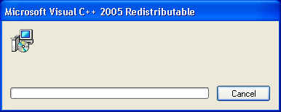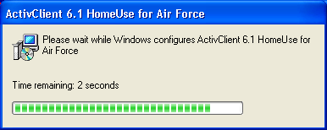
Windows Vista Screenshot
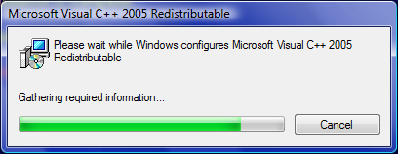
- When Step 3 is complete, “in process” (in red letters) turns to “completed” (in green letters), and Step 4 begins as indicated by “in process” (in red letters). It is now installing the OWA component.
- When Step 4 is complete, “in process” (in red letters) turns to “completed” (in green letters), and Step 5 begins as indicated by “in process” (in red letters). It is now installing ActivClient 6.1.
Note: If ActivClient 6.1 is already installed, a prompt will appear similar to the following:
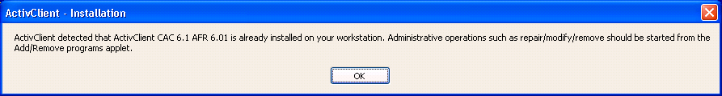
Click the OK button. If there is a patch or other upgrade, that will be loaded at this time. If ActivClient 6.1 is already installed, skip to paragraph 2.3.
Next, a prompt will appear indicating a Windows Installer is preparing to install.
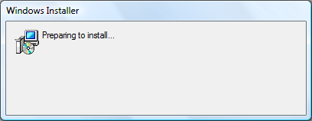
Note: In a Windows Vista operating system, when the Windows Installer begins to install ActivClient 6.1, a warning prompt appears stating “An unidentified program wants access to your computer.” There are two options; “Cancel” or “Allow.” Select Allow.
- Next, a prompt appears advising you to wait while Windows configures ActivClient 6.1. It will first indicate it is gathering required information, and then will reflect the time remaining for installation.
Windows XP Screenshot
Windows Vista Screenshot
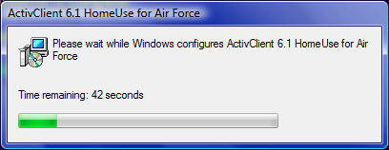
Note: In a Windows Vista operating system, the following window will appear during the installation process. Click OK to continue.
Windows Vista Screenshot
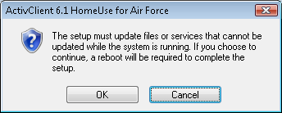
- A prompt will appear indicating that the installation is complete and it will instruct you to reboot the workstation when practical in order to access all ActivClient 6.1 features. Click OK and reboot the computer; it will not automatically reboot.
Windows XP Screenshot
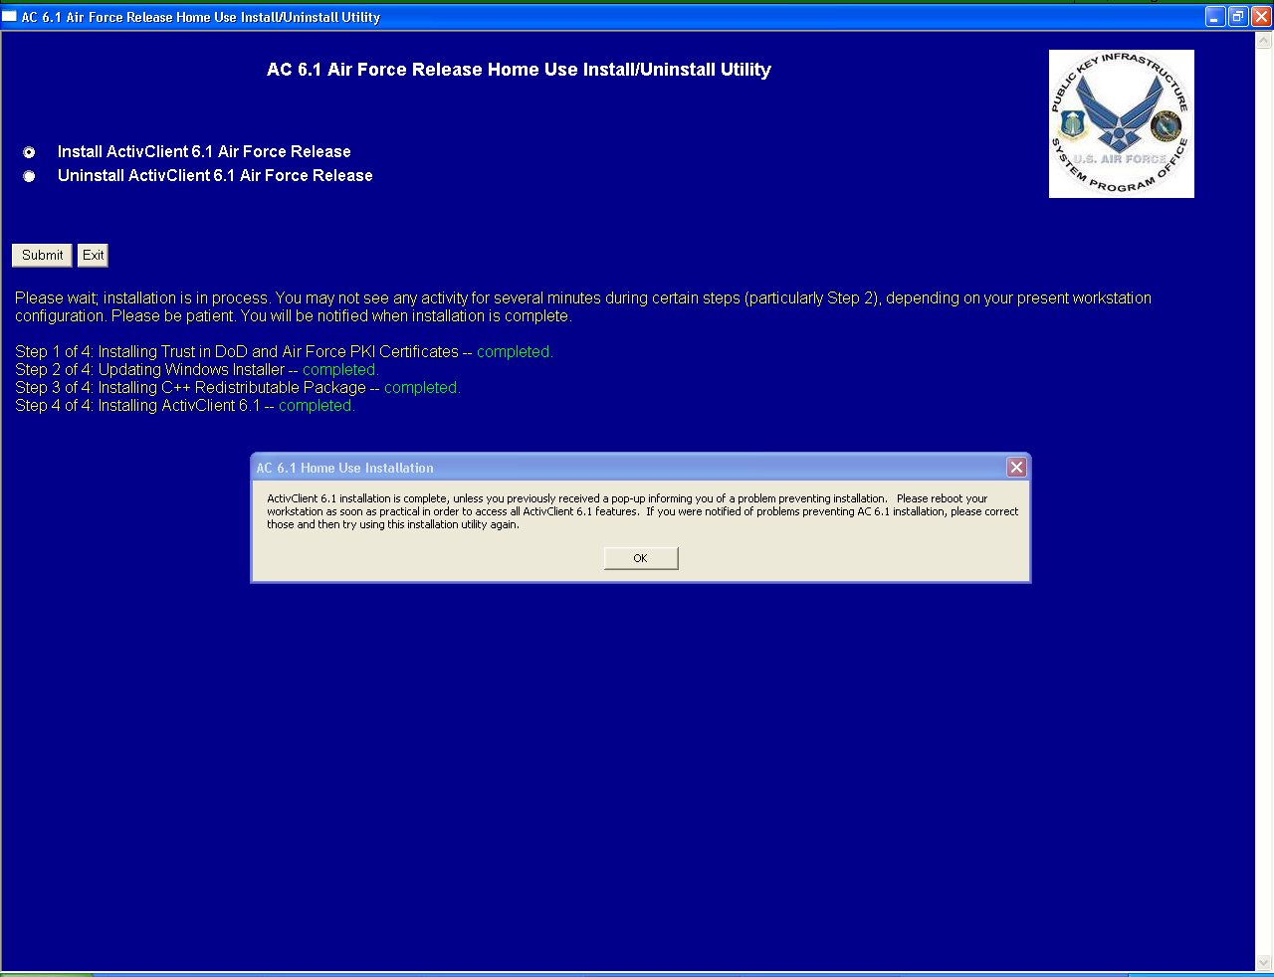
Windows Vista Screenshot
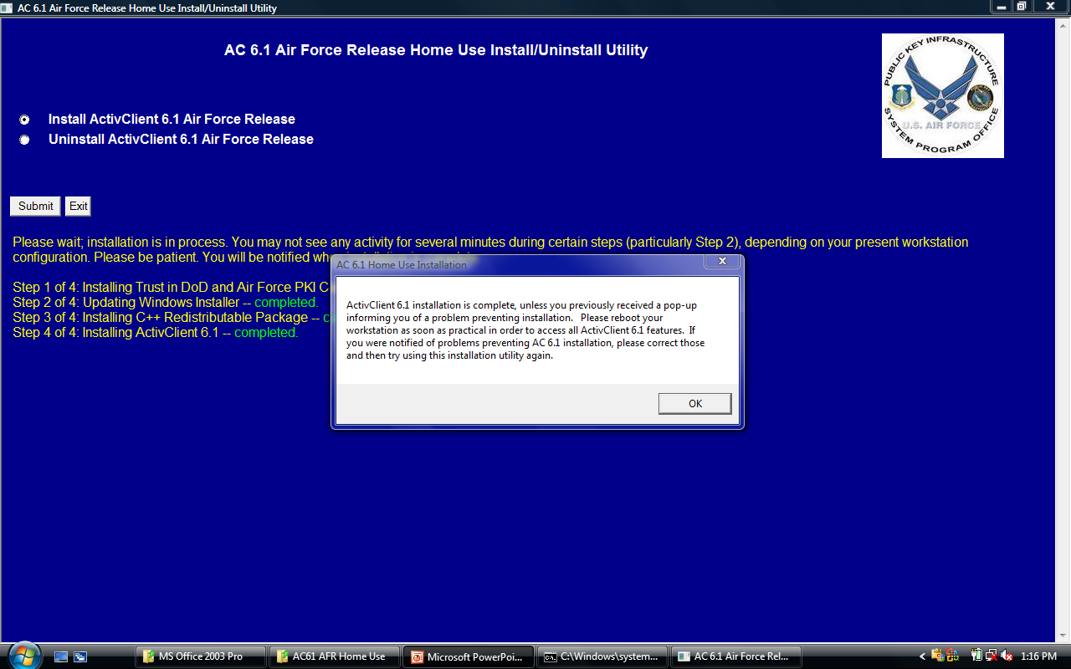

Smart Card Reader Installation Instructions
It is best to shut down the computer before installing a smart card reader. With the computer turned off, plug in the smart card reader and then start the computer.
If the computer automatically detects and installs the smart card reader drivers, no further action is necessary. Smart card reader drivers already exist on many computers. However, the computer may seek smart card reader drivers via the Internet and provide prompts to install them when found.
If the computer did not detect and install the smart card reader, use the instructions and smart card reader drivers that come with the smart card reader to accomplish the installation. If you do not have instructions (or smart card reader drivers), then you may be able to obtain them from the smart card reader vendor’s Web site or via an Internet search. If you obtained the smart card reader from a military source and do not have installation instructions or drivers, consult your CSA.
Reboot your computer after installing the smart card reader and its drivers.
Table 2-1 lists some of the most common smart card reader vendors and links to their Web sites. This list is not all-inclusive, and the AF does not recommend one over another. There are many other sources from which to purchase smart card readers (local and online retailers and online auctions).
Table 2-1. Smart Card Readers
Smart Card Reader | Vendor Web Site Links
Schlumberger/Axalto | www.readers.slb.com
SCM SCR | http://www.scmmicro.com/security/secure_card.html
GoldTouch Keyboard | http://www.keyovation.com/
Infineer | http://www.mako-tech.com/pands/reader_sol.cfm
Dell | www.dell.com
ActivCard or ActivIdentity | http://www.actividentity.com/products/smart_cards_readers__home.php
USB smart card readers are the preferred smart card readers.
Personal Computer Memory Card International Association (PCMCIA) smart card readers work on most laptops. However, many laptops have only one PCMCIA slot, often already used for other purposes such as a wireless Local Area Network (LAN) card. A Universal Serial Bus (USB) smart card reader is often a better choice, even for laptops.
Serial smart card readers are not recommended, but will operate on most workstations. For the middleware to function properly, install the serial smart card readers on COM port 1.

Verify Installation Success
After the computer reboots, insert your CAC into the smart card reader. Double click the ActivClient 6.1 icon located in the system tray (lower right-hand corner of the desktop).
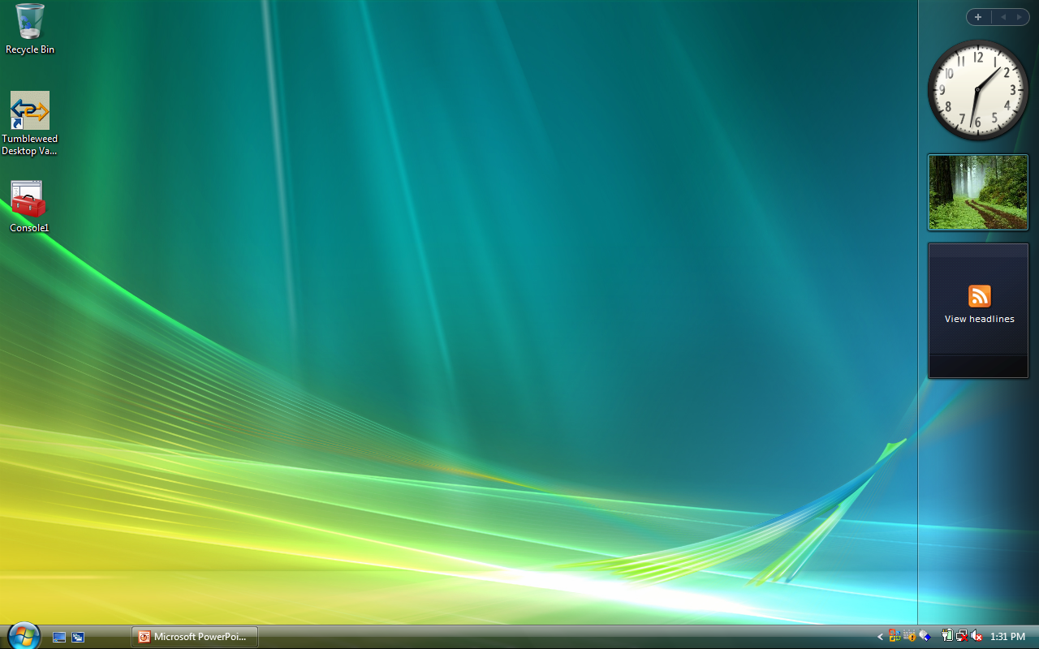
Double clicking the ActivClient icon should produce the following window, indicating you can successfully access your CAC.
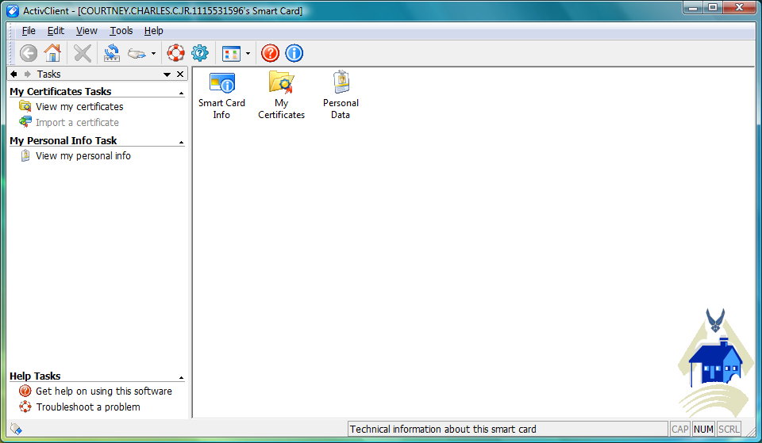

Uninstall Instructions

Uninstall Home Use Middleware
The following instructions explain how to uninstall Home Use Middleware from your computer. There are two options to uninstall the middleware. The first option is to use Add/Remove Programs on the Control Panel.
- Click the Start button. (Note: If you are using Windows 2000 or the classic view, you will need to click on Settings after clicking the Start button).
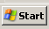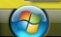
Windows 2000 or XP Vista
- Click Control Panel from the menu.
Windows 2000 or XP Vista
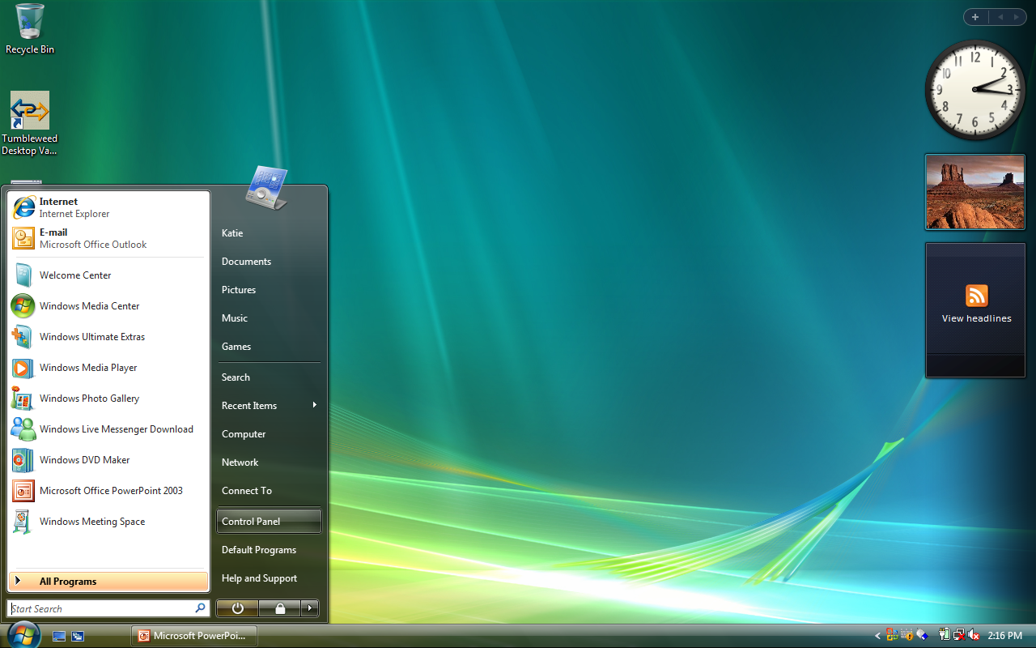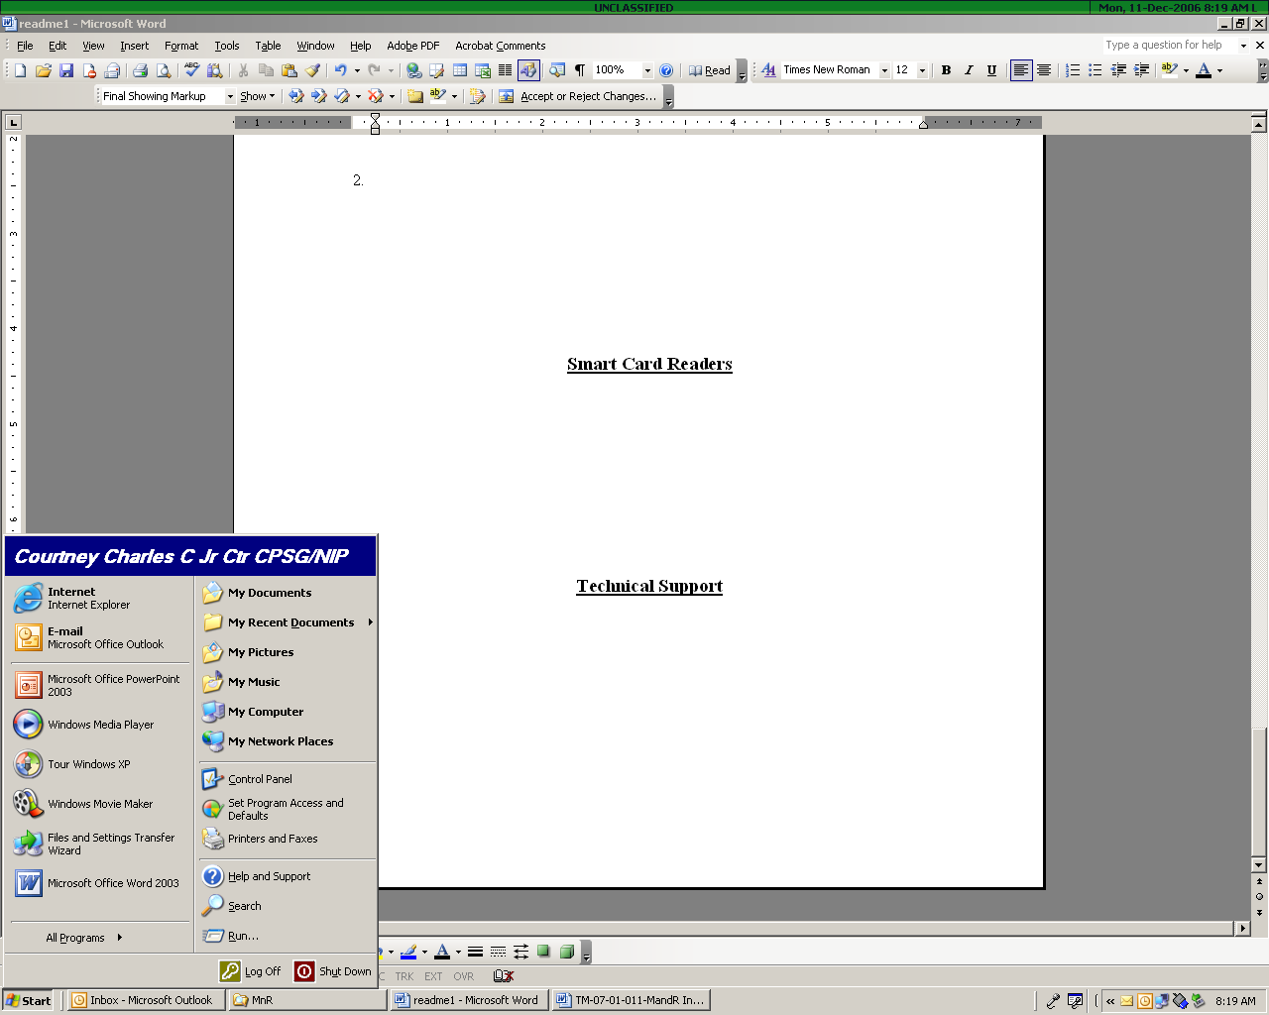

- In Windows 2000 and XP, click Add or Remove Programs. When the list of programs installed on your computer appears, highlight the ActivClient 6.1Home Use for Air Force program and click Remove.
(Windows XP Screenshots)
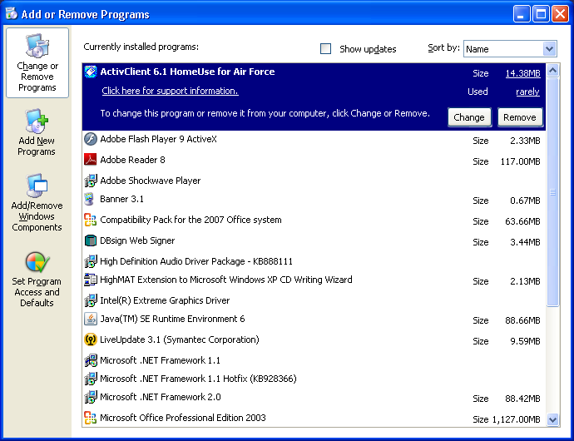
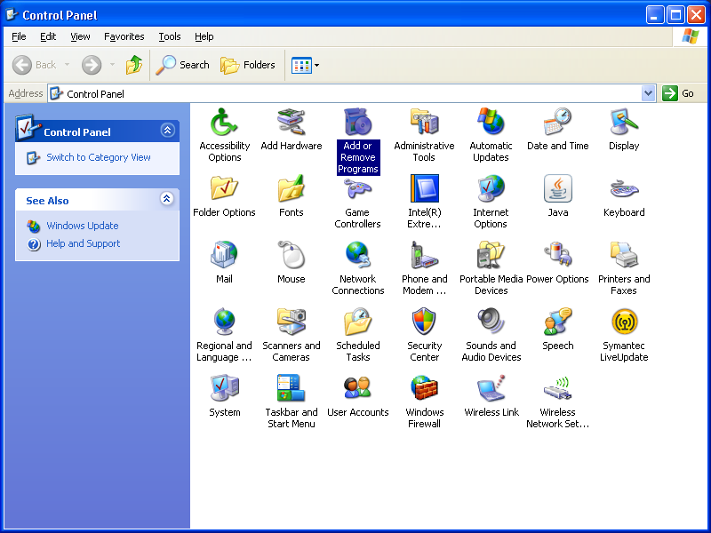
In Windows Vista, click Uninstall a Program. When the list of programs installed on your computer appears, select ActivClient 6.1HomeUse for Air Force program, and click Uninstall.
Windows Vista Screenshots
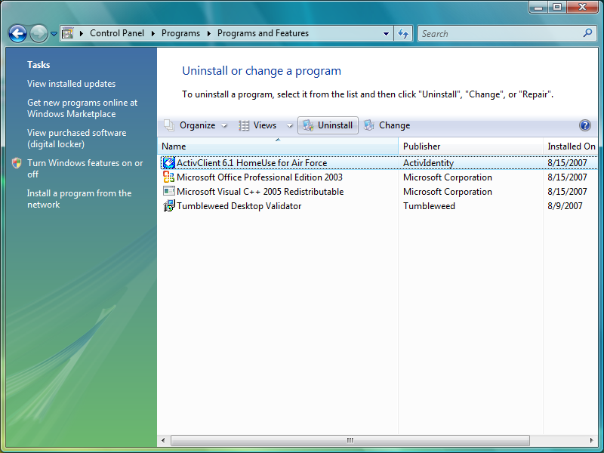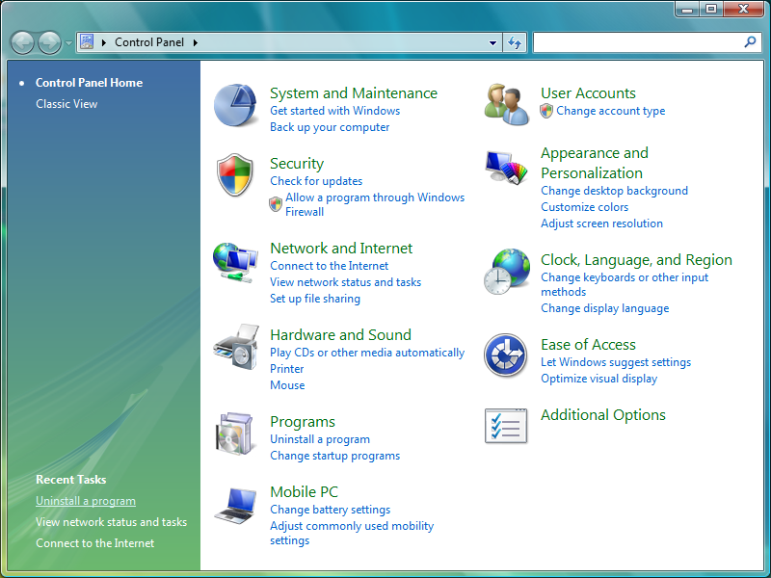

- A prompt will appear asking if you want to uninstall AC 6.1. Click Yes to remove the program.
Windows XP Screenshot
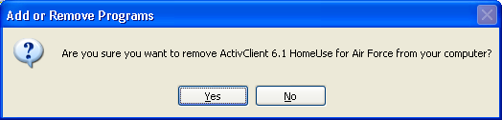
Windows Vista Screenshot
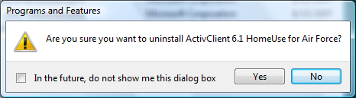
- Windows will provide a progress indicator, reflecting that the middleware is being uninstalled.
Windows XP Screenshot
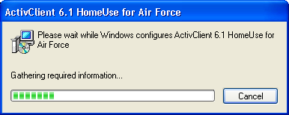
Windows Vista Screenshot
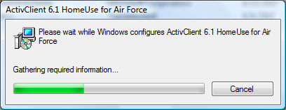
- Reboot your computer when prompted; click Yes (in XP) or OK (in Vista); see screenshots below.
Windows XP Screenshot
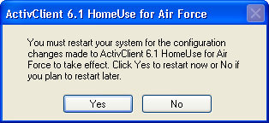
Windows Vista Screenshot
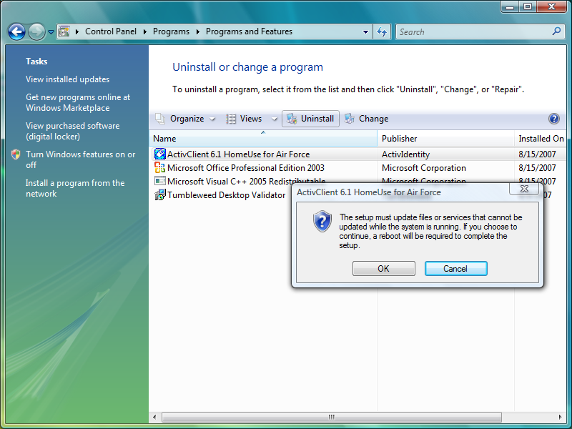
Note: In a Windows Vista operating system, when ActivClient 6.1 begins to uninstall, a warning prompt appears stating “An unidentified program wants access to your computer.” There are two options; “Cancel” or “Allow.” Select Allow.
Windows Vista Screenshot
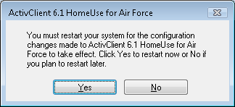
Note: Another option to uninstall the middleware is to go to the folder where the middleware file “ClickHeretoInstallorUninstall” is located and double click on that file to accomplish an uninstall, just as you did when you initially installed the middleware.

Technical Support
If you experience difficulty installing or uninstalling Home Use Middleware or a smart card reader, contact your local CSA or your local Help Desk at the servicing Communications Squadron. The Air Force Public Key Infrastructure System Program Office (AF PKI SPO) does not provide technical support to home users.
Appendix A
Acronyms
AF | Air Force
AFRES | Air Force Reserve
ANG | Air National Guard
CAC | Common Access Card
CSA | Client Support Administrator
DoD | Department of Defense
FOUO | For Official Use Only
LAN | Local Area Network
NAF | Non-Appropriated Fund
PCMCIA | Personal Computer Memory Card International Association
PKI | Public Key Infrastructure
SP | Service Pack
SPO | System Program Office
USAF | United States Air Force
USB | Universal Serial Bus

